Lesson Plan: Explore Careers by Interviewing Professionals

Overview
In Explore Careers by Interviewing Professionals, students will write interview questions and conduct an interview.

Objectives
By the end of this lesson, students should be able to:

- Achieve the following objective(s):
  - Explain why interviewing someone in an interesting field would be useful to a job search or career planning.
  - Prepare relevant and useful questions for a career-oriented interview.
  - Record questions and answers in a document.
- Answer the following essential question(s):
  - Why is it valuable to interview people working in a field I find interesting?
  - What questions can I ask during an interview to improve my understanding of a career?
- Internalize the following enduring understanding(s):
  - I can use Google Docs to gather research about jobs and careers.
  - Writing interview questions and then conducting an interview is a useful and effective way to gather information about a career.
Digital Skills
As they complete this lesson, students will learn and practice the following digital skills:
- Open a document
- Add text to a document
- Format a document
- Edit a document
- Complete a spell check
Terms and Concepts
As they complete this lesson, students will learn and use the following terms and concepts:
- Informational Interview
- Interview subject
- Conducting an interview
- Career field
- Format
Total Duration | Materials
- 45 minutes (can be extended to 90 minutes with extension videos) | - Computer with internet access (per student)  - Headphones (per student)  - Applied Digital Skills website

Lesson Outline: Main Videos Plus Extensions
 | Video | Duration | Description
1 | Introduction to Explore Careers by Interviewing Professionals | 5 min | Students are introduced to the lesson, create a new document, and give it a title.
2 | Choose Someone to Interview | 5-10 min | Students research potential candidates for an interview about a career.
3 | Write Your Interview Questions | 10 min | Students add interview questions to their document.
4 | Conduct Your Interview | 10 min | Students conduct their interview and add responses to their document.
5 | Explore Careers by Interviewing Professionals Wrap-Up | 5 min | Students wrap up the lesson and discover how the skills they learned can apply to other tasks.
* | Extension A: Write an Email to Request an Interview | 10 min | Students write an email to a professional to request an interview about a career field of interest.
* | Extension B: Revise Your Questions for a Different Interview | 10 min | Students revise their original questions for an interview with someone in a different job.
* | Extension C: Create a Survey Using Interview Questions | 15 min | Students create a survey to send to professionals to gather information about a career field.

Prep
Before introducing this lesson to students:
- Create a teacher account at g.co/applieddigitalskills, and add a class.
- Distribute the class code to your students.

Procedure
- Introduce the lesson: Prompt students to think about writing interview questions and conducting an interview (see Appendix for suggested prompts).
- Check in with students during class: Meet one-on-one or in small groups as students watch videos (see Appendix for suggested prompts).
- Wrap up the lesson: Give a short closing and facilitate brief discussion about what students learned and experienced (see Appendix for suggested prompts).

Check Outcomes
Walk around class and monitor progress to ensure students:
- Rename a document.
- Research potential interview subjects.
- Add interview questions to their document.
- Number the questions.
- Format the document to allow space for responses.
- Add responses to the document during the interview.
Assessments
- Use the reflection (answer key) at the end of this lesson to assess what students have learned about writing interview questions and conducting an interview.
Resources
- Example project
- Project Evaluation Rubric
- Appendix

Tip: This lesson is designed to be completed in a single class period. It has multiple videos for students to watch, which vary in duration and guide students through building a main project around a central theme. Also included are three optional extension videos, which should each take students 5-10 minutes to complete. They can be added to the main lesson to extend instructional time and allow students to add on to their projects and reinforce skills.

Tip: Assign groups. Some videos require students to work in pairs or groups. Save time by assigning students before the lesson begins.

Tip: Reserve 5 minutes at the beginning and end of each lesson. Start each class with a 5-minute introduction and end each class with a 5-minute closing.

Tip: Use the rubric to evaluate student work. Rubrics are linked in each lesson plan to evaluate student work. Share a copy of the rubric with students before they turn in their projects.

Example Student Outcome (Add contact information to the document.)
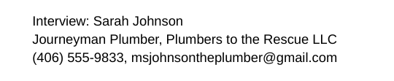

Example Student Outcome (Write and format interview questions.)
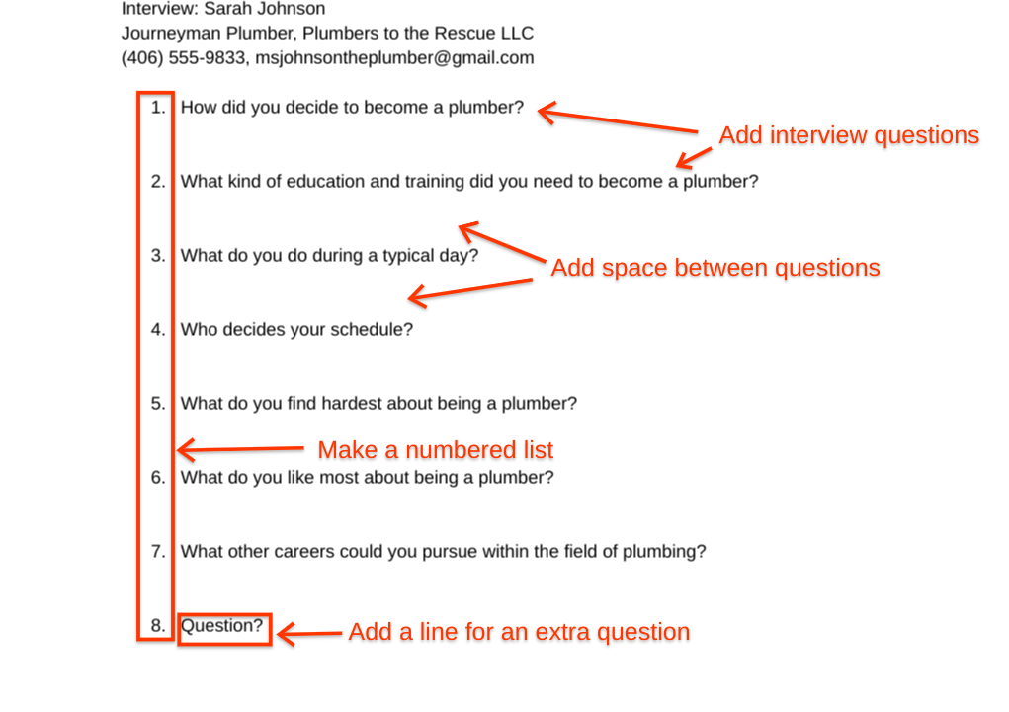

Example Student Outcome (Conduct an interview and record responses.)
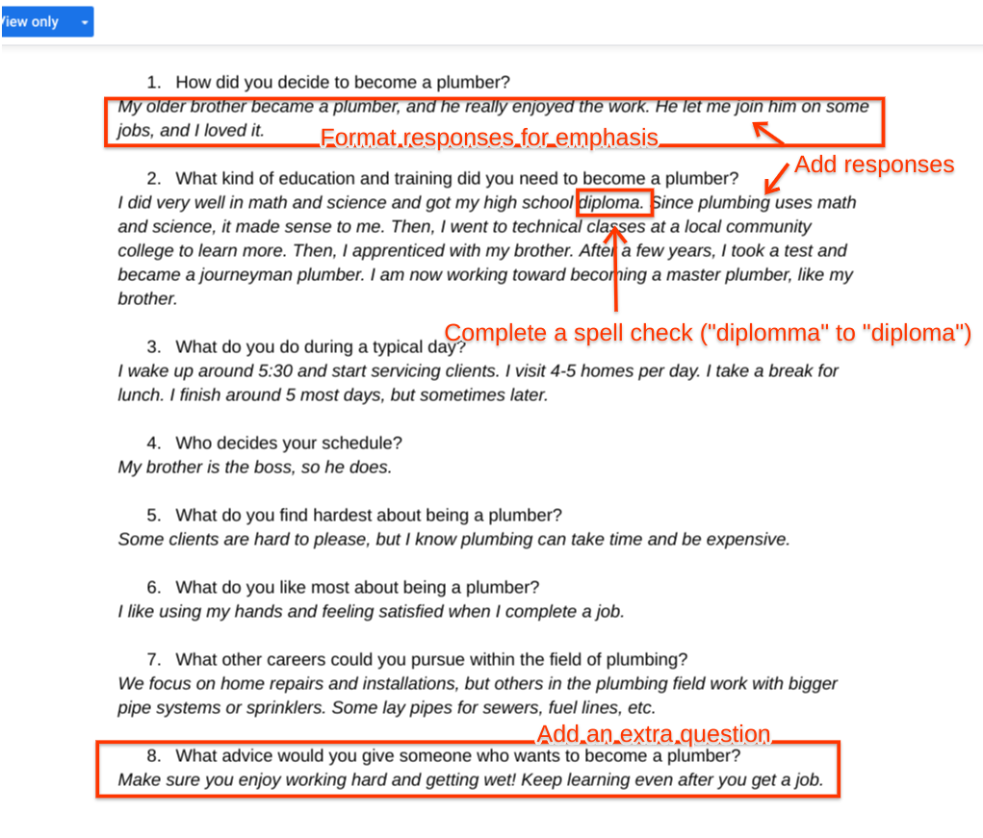

Example Student Outcome: Extension A (Write an email to request an interview.)
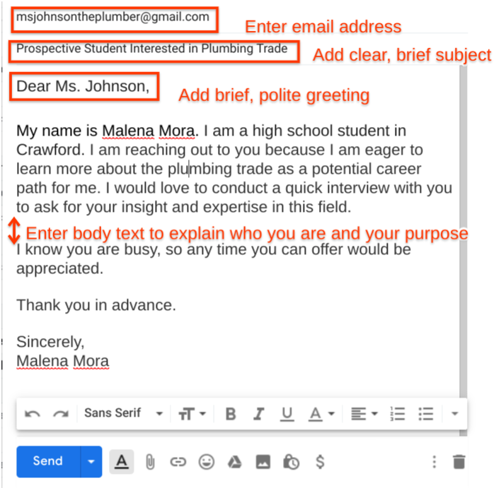

Example Student Outcome: Extension B (Revise questions for a different interview.)
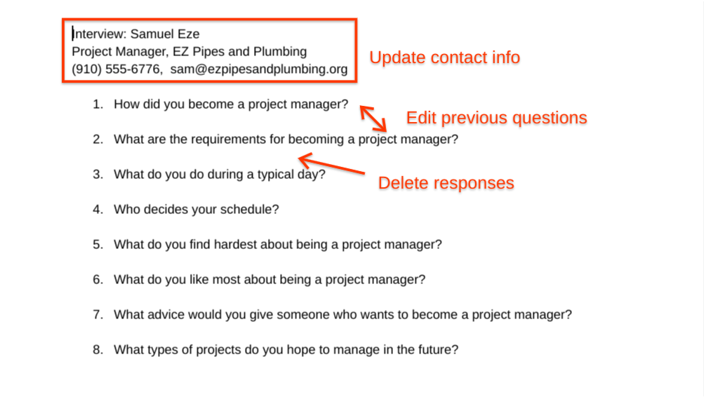

Example Student Outcome: Extension 3 (Create a survey using interview questions.)
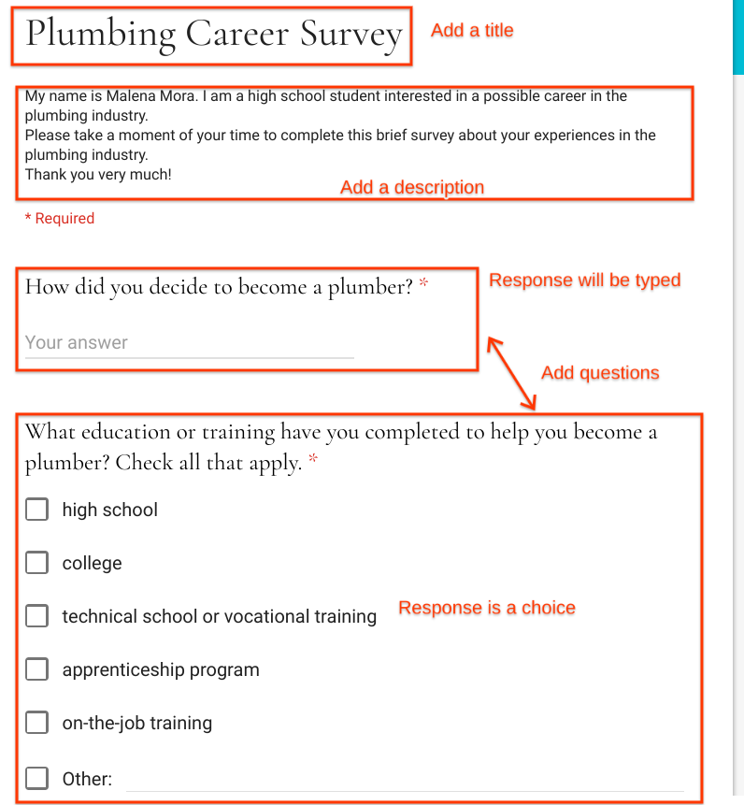

Appendix

Explore Careers by Interviewing Professionals

Introduce the lesson and prompt students to think about writing interview questions and conducting an interview.
Say | To get started and join our class, go to g.co/applieddigtialskills and select “Sign In.” Click on your Google account (or create one), choose “I am a student,” and enter our class code. (Teacher note: Locate your class code on your dashboard.) After you join our class, proceed to Video 1 and begin watching.
Ask | - What are some ways to learn about a career field?  - How can conducting an interview help you gather information?  - How can you make a document sound professional?

Describe the activities and outcomes for the lesson.
Say | In this lesson, you will write interview questions and conduct an interview.
Say | Go to g.co/applieddigitalskills and select “Sign In” to log into your profile. If you see “Wait,” click it and move onto the next unit. If you already see “Introduction to Explore Careers by Interviewing Professionals” then you are ready to begin watching the first video. Watch the first video, and complete the steps described.
Teacher Note | If students need help accessing the lesson, have them navigate the curriculum menu by clicking on “Curriculum” at the top of the page, then scrolling down and selecting the correct lesson.
Intro/Closing Questions | - What are some questions you might ask someone about their career?  - Which questions might be inappropriate to ask?
Engage | - Which question might help you learn the most about a career? Why?

Wrap up the lesson.
Wrap-Up | Summarize the lesson and celebrate that, as a result of the skills learned, they created an exciting project.
Say | In this lesson, you wrote interview questions and conducted an interview.
Ask | - How much were you able to learn from your interview?  - Tell about any questions you added during the interview. Why did you add them?  - How will you apply the new skills you learned here to your life or work?

Reflection Answer Key
- A
- D
- C
- A
- B
- C
- A
- C
- (Open-ended)
- (Open-ended)
- (Open-ended)
- (Open-ended)

Evaluating Open-ended Responses

Question 9:
- Look for responses that include one of the following concepts:
  - Interviews with a career professional give you information you can’t get elsewhere
  - Interviews with a career professional help you understand what that work is really like

Question 10:
- Look for responses that include one of the following concepts:
  - Preparing questions helps you feel more comfortable
  - Preparing questions makes your interview more effective

Questions 11 and 12:

Responses to these two questions can be used to:
- Identify concepts and/or skills that students may need additional instruction on or practice with to fully understand.
- Identify where the digital skills and concepts could be embedded in future classroom activities and assignments.
- Identify if students are making connections between the digital skills and concepts covered in this lesson and how they can use those digital skills and concepts in different settings or on different assignments.

